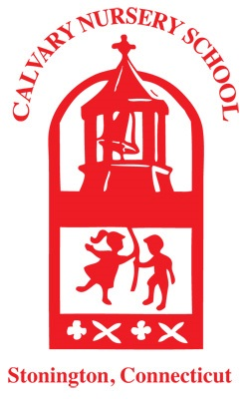
Calvary Nursery School – Interest Form 2026-2027

Please fill out and send back to Sally Booth, Director, Calvary Nursery School
Nurseryschool@calvarychurchstonington.org
Or: 27 Church Street, Stonington, CT 06378

Child’s Name_____________________ Date of Birth__________ Sibling of CNS child or alum? (yes/no)

Parent Name____________________________ Address___________________________________________

Phone________________ Email___________________________

Parent Name____________________________ Address___________________________________________

Phone________________ Email___________________________

How did you hear about Calvary Nursery School? _______________________________________________

Has your child ever attended any nursery school, childcare, or other group experience? ______________

Please describe briefly:

__________________________________________________________________________________________

__________________________________________________________________________________________

We offer a 5-hour program, with a full day option until 4:00 PM. Children start arriving at 8:00 with the day formally starting at 8:40 AM. Children stay for lunch daily. Children leave for home at 1:00 PM for half day session. Full day will have a rest period of 45 minutes with pick up by 4:00 PM. Music & Movement classes, weekly visits to NESS, and walks in the Borough include all children regardless of schedule selection.

Please indicate your child’s preferred schedule (Please circle and indicate first & second choices.)

Half Day T/Th Half Day M/W/F Half Day M-F

Full Day T/Th Full Day M/W/F Full Day M-F

